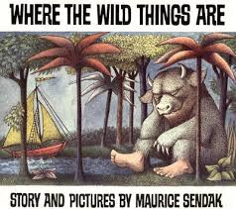
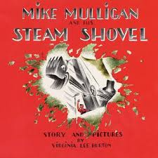
RMAE Children’s Book Project- 8th Grade Collaborative Writing Project

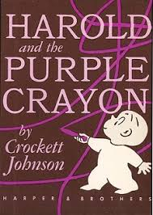
Goal: Focus on the writing processing using group collaboration as well as creating an end-product that can be turned into a high quality children’s book.

Reasoning: Little kids love to read and have their favorite books read aloud to them. Why? Because these books tap into what they know and love: empathy, love, pride, discovery, adventure, and joy (among so many others) all while teaching them lessons about life, not to mention new vocabulary words. Good children’s book incorporates all the elements of the best, most impressive writing at a minimalist level.

Your task: Each group will model, write, and illustrate a children’s book for age’s 4-7 years old.

The writing process must include the following:
- An original story line (ideas coming from your kinder buddies!)
- Research- some of you will have to speak with other children, teachers, authors in the area, family members, look things up on the internet for inspiration. All strong writing includes research, but you need to give credit to your sources in MLA format at the end of your story.
- Focus on word choice- what words sound more interesting; which are more fun to say? Which words do children want to include?
- Figurative language- yes, even kids books use onomatopoeia, simile, metaphor, personification, allusions, hyperboles, and of course LOTS of imagery!
- Sentence variation- Don’t dumb it down! Make it fun to read!
- Editing and Revising- and LOTS of it! Every word, paragraph, punctuation mark and even extra spaces on the page are all important and impactful in a children’s book.
- Illustrations: yes, your group must illustrate this. Your story line must be complete before you begin illustrations and more than one person must work on the illustrations.
- Layout/ Font- when you’re putting all the pieces together, every space, word, and image on each page is important. How will your book be bound? How thick are the pages? What size font? How many pages does it have? Is it easy for a kindergartener to read? Can they hold the book easily? Does it bend or tear with little hands?
- Acknowledgments/ Glossary/ Credits/ Biographies/ Dedication/ Table of Contents- All of these are often included in children’s books. You should plan to include them all!
  - Acknowledgments/Credits: since children’s books don’t have word cited pages, this is where you give credit to your sources (aka the kinders!)
  - Glossary- if you use lots of the unfamiliar/ bigger words, feel free to include a short glossary at the front or the back of the book. The definitions should be short and readable for a kindergartener.
  - Dedication: you should dedicate it to the kindergarten kiddos (know their name) you worked with on this project!
  - Table of Contents: not always necessary, but if you have chapters or sections, you should label them accordingly.

End product: A complete children’s book created by your group of 8th graders specifically for your audience of kindergarten kids. You will present the book to the kindergarten class on the last day of school!

